Exercise 7
- List the names of 5 youngest employees in the company.
Answer: SELECT f_name, l_name, age
FROM employee_data
ORDER BY age ASC
LIMIT 5;

- Extract the next 5 entries starting with the 10th row.
Answer: SELECT *
FROM employee_data
LIMIT 9, 5;

- Display the names and salary of the employee who draws the largest salary.
Answer:
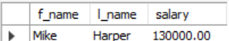

- What does the following statement display?
Answer:
